**SMART STAR EXAMINATIONS BOARD**

**END OF TERM ONE EXAMINATION - 2024**

**SOCIAL DEVELOPMENT**

**MIDDLE CLASS**

My name is…………………………………………..

1. **Tick people at home.**

|  |  |  |
| --- | --- | --- |
| BOY |  | C:\Users\FAITH\Pictures\images (2).png |
|  |  |  |
| C:\Users\Public\Pictures\may-day-basket-printable.gif | **E:\PICTURES\Typist Diagrams\Scholastic\bag.jpg** | baby |

1. **Put the missing parts. *(3marks)***
2. 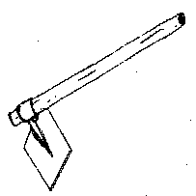**Read and match.**

**axe**

**hoe**

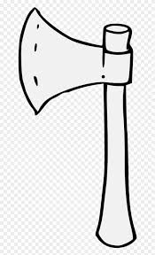

**water**

1. 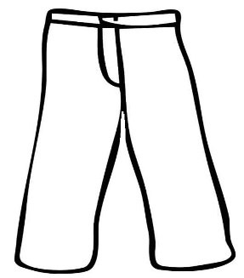**Match to the belongings.**

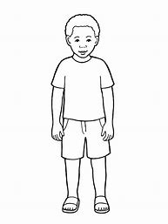

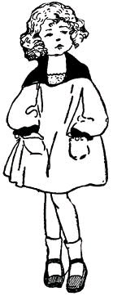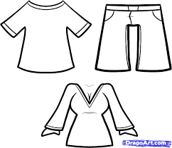

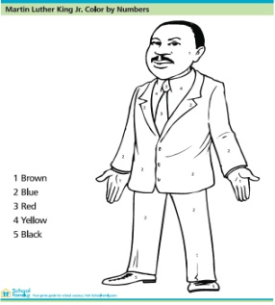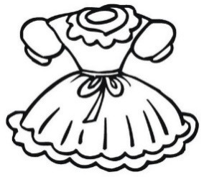

1. **Draw yourself.**
2. **Read and draw.**

|  |  |  |
| --- | --- | --- |
|  |  |  |
| **cat** | **hen** | **duck** |

1. **Oral**

**In which class are you?**

**How old are you?**

**How many days make a week?**

**Who are your teachers?**

**END**